Physics 3A/3B

Motion and Forces in a Gravitational Field

Test 3

Torque and Structures

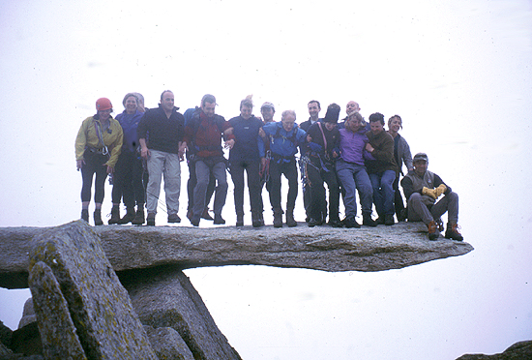

Time allowed: 40 min
Answer all questions on the paper provided
To achieve full marks, clear, logical
working and diagrams MUST be shown.
Answers should be evaluated with an
appropriate number of significant figures.

Section A: 4 Short answer Questions ( 12 marks )

1. Explain with the aid of diagrams why a person carrying a large box must adjust their balance by leaning?

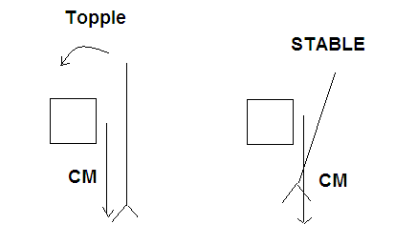

(1) for Diagrams
Combined(new) CM is no longer over base of support. Person must lean to Bring line of action of CM within the base of support, or destabilizing torque will result in them toppling. (2)

(3 marks)

2. People with severe arthritis in their hands often have difficulty turning taps on and off. A tap- making company has recognised this and developed a device that fits over the tap and has two arms as shown in the diagram.

Explain the principle upon which this device operates.
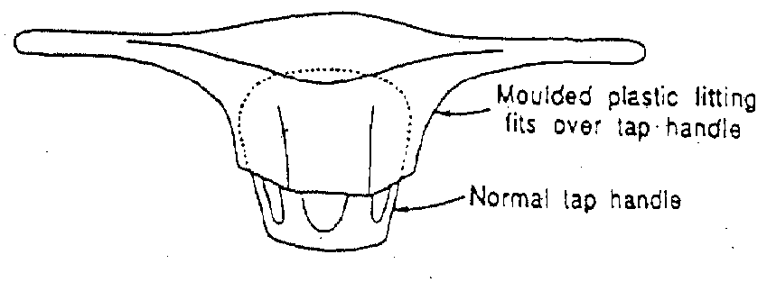

(3 marks)

Torque ( moments ) ( 1)
T = F x r
Torque or turning effect is the product of applied force and the Perp distance to the pivot. (1)

By increasing r of tap increase T for same force. (1)

3. Calculate the force exerted by a biceps muscle when lifting a 3.00 kg mass. Assume the biceps muscle is attached 40.0 mm from the elbow joint and acts at right angles to the bone. The lower arm has a mass of 1.70 kg and is considered uniform.
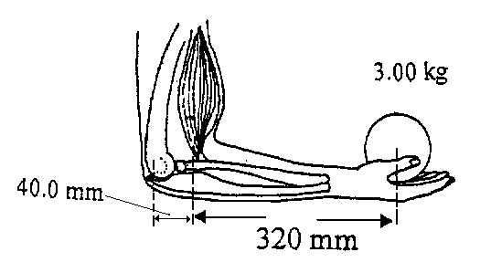

(3 marks)
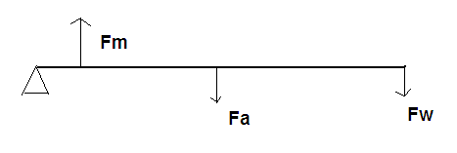

∑m = 0
∑ACWM = ∑CWM
_{m}xr = F_{a} x r + F_{w} x r (1)
F_{m}x 0.04 = (1.7 x 9.8) x 0.18 +(3 x 9.8) x 0.36 (1)
F_{m} = 3.40 x 10² N (1)

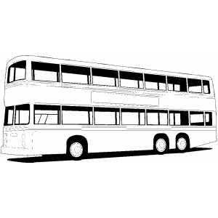
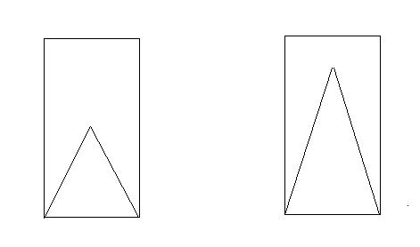
4. Explain with the aid of diagrams, why a double-decker bus becomes less stable as people are loaded into the upper deck of the bus? (3 marks)

-CM increases in height (1)
-Less toppling force required to move
LOA CM outside the base of support (1) Diagrams (1)

Section B: 3 Extended answer questions: marks

1. A shopkeeper wants to hang two signs from a 10.3 kg horizontal pole fixed to the wall. The first sign has a mass of 5.20 kg and is to be hung 0.800 m from the wall. The second sign has a mass of 6.60 kg and is to be hung 0.200 m from the free end of the pole. The pole is 2.00 m in length. If the pole is to be supported by a vertical cable from the roof, the cable can only support 1.40 x 10² N, what is the minimum distance from the wall that the cable can be attached?
(4 marks)
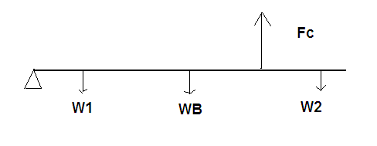 ∑m = 0
∑ACWM = ∑CWM
Fc x X = W1 x r + WB x r + W2 x r (1)
1.40 x 10² x X = (5.2 x 9.8) x 0.8 + (10.3 x 9.8) x 1 + (6.6 x 9.8) x 1.8 (1)
1.40 x 10² x X = 40.768 + 100.94 + 116.424
X = 1.84 m (2)
(4 marks)

2. An 85 kg painter is using a plank, which rests on two trestles, to paint the upper section of a wall as shown.
Assuming that the plank is uniform and has a mass 15 kg:

- calculate the forces exerted by each trestle on the plank if the painters stands at trestle A.

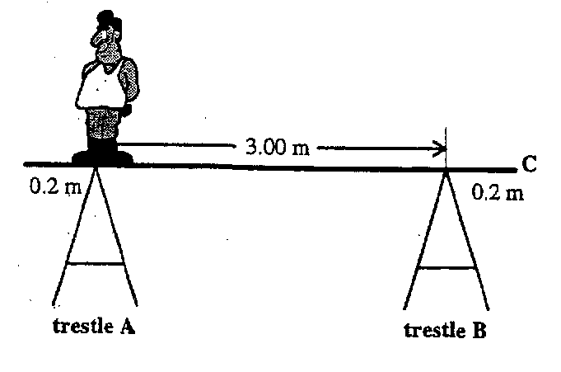

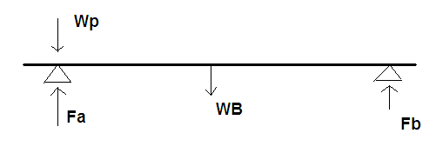
∑M = 0
∑ACWM = ∑CWM
Fb x r = Wb x r
Fb x 3 = (15 x 9.8) x 1.5
Fb = 73.5 N (3)

∑F = 0
Fa + Fb = Wp + Wb (1)
Fa = (85 x 9.8) + (15 x 9.8) - 73.5
= 907 N (1)
(5 marks )

- if the painter then stands at the end of the plank (point C), will the system remain in equilibrium? Justify your answer. (3 marks )

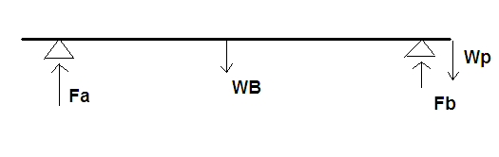

About B
ACWM = Wb x r
= 15 x 9.8 x 1.5
= 220.5 Nm (1)

CWM = Wp x r
= 85 x 9.8 x 0.2
= 166.6 Nm (1)

ACWM ≥CWM YES (1)
Or
∑M = 0
∑ACWM = ∑CWM Assume Fa down
Fa x r + Wb x r = Wp x r
Fa x 3 + 220.5 = 166.6
Fa = - 18.0
Fa = 18 up
Fa ≥ 0 Yes
